What diabetic retinopathy is, and what each grade in this dataset means
Diabetic retinopathy is damage to the blood vessels in the retina, the light sensitive tissue at the back of the eye, caused by long term high blood sugar from diabetes. It is one of the leading causes of preventable blindness in adults worldwide. Because it usually causes no symptoms in its early stages, regular retinal screening (photographing the back of the eye and having it graded, either by an ophthalmologist or, increasingly, by an automated model like the ones in this project) is the main way it gets caught early enough to treat before permanent vision loss occurs.
All three datasets in this task use the same five point grading scale, from 0 (no visible disease) to 4 (the most severe, sight threatening stage). In plain terms:
- Grade 0, no DR: no visible signs of diabetic retinopathy in the photograph.
- Grade 1, mild: the earliest visible sign, small bulges in the tiny blood vessels of the retina called microaneurysms, essentially small weak spots in the vessel wall.
- Grade 2, moderate: more blood vessel damage, including vessels that have started to leak blood or fluid into the retina, but not yet at a severe stage.
- Grade 3, severe: significant blockage of blood flow to parts of the retina, depriving that tissue of oxygen. This is the stage that most urgently signals a high risk of progressing to the final, sight threatening stage.
- Grade 4, proliferative DR: the retina, starved of oxygen, starts growing abnormal new blood vessels to compensate. These new vessels are fragile and prone to bleeding, and this stage carries the highest risk of severe, permanent vision loss if untreated.
This is why the grading task is ordinal (the classes have a genuine order of increasing severity, unlike the skin lesion task's categories, which are different disease types with no inherent order) and why the rare, severe classes (grade 3 and especially grade 4) matter disproportionately for a model to catch correctly, even though they make up a small fraction of any real world screening population.

2. The Data, Exactly As Verified
These counts were confirmed directly against the actual files on the Kaggle platform, not assumed from documentation. Every image path was sample checked to confirm it actually resolves to a real file before any training began.

The three sources
APTOS 2019 is a dataset released as part of a Kaggle competition by the Asia Pacific Tele-Ophthalmology Society. It contains 3,662 retinal fundus photographs, taken with a range of camera equipment and under varying imaging conditions, reflecting real world clinical screening rather than a single controlled setup. It is a single resolution family in the sense that its images fall into 15 distinct resolutions, the median image being 1536 by 2048 pixels.
EyePACS is a much larger dataset, originally released for the 2015 Kaggle diabetic retinopathy competition and re-hosted in a resized form. The full EyePACS 2015 training set contains 35,126 images. It is a genuinely diverse dataset in acquisition terms, spanning 81 distinct image resolutions in our sample, the widest variation of the three sources, reflecting that it was collected across many different screening sites and camera setups rather than one clinic. For this project, EyePACS was subsampled down to 3,662 images (matching APTOS's size) to avoid one source overwhelming the pooled training set, with the subsampling done at the patient level and checked to preserve the original grade distribution within 3 percentage points per class.
Messidor-2 is a dataset that in this project's copy comes already preprocessed to a single fixed size, 512 by 512 pixels for every image, unlike the other two sources which contain many different original resolutions. It contains 1,744 images. Its filenames reveal two different underlying naming conventions, one modern (a date, session, and eye side embedded directly in the filename) and one older style, which turned out to matter for how patient identity had to be recovered, described in the gotchas section below.

Class distribution, exactly as counted
Grade | APTOS | EyePACS (subsampled) | Messidor | Pooled
0 (no DR) | 1,805 | 2,694 | 1,017 | 5,516
1 (mild) | 370 | 240 | 270 | 880
2 (moderate) | 999 | 559 | 347 | 1,905
3 (severe) | 193 | 90 | 75 | 358
4 (proliferative) | 295 | 79 | 35 | 409
Total | 3,662 | 3,662 | 1,744 | 9,068
In plain terms, grade 0 (no disease) is the overwhelming majority in every source, and grade 4 (the most severe, sight threatening stage) is the rarest, especially in Messidor where it is only 35 images out of 1,744. This imbalance is why class weighting is used during training, and it is important context for reading every result below, a model that simply guessed grade 0 every time would already score well above chance on raw accuracy without learning anything real.

Train, validation, test split
Each source uses a splitting rule appropriate to what patient identifying information is actually available in it. APTOS has no recoverable patient identifier, so its split is done at the image level. EyePACS has a patient identifier extractable directly from its filenames, so its split is done at the patient level, meaning both eyes of the same patient always stay together on the same side of the split. Messidor is split in two parts, described below, because only part of it has a recoverable patient pairing signal.
Split | Train | Validation | Test
Pooled | 6,344 | 1,361 | 1,363
Patient level leakage (the same patient's images appearing on both sides of a split) was checked programmatically for both EyePACS and the pairable portion of Messidor, not assumed. Both checks passed with zero overlap.

The Messidor pairing problem, and how it was actually resolved
Messidor's 1,744 images split into two groups by filename style. 1,057 use a modern naming convention with a date, session ID, and eye side code, but on inspection, checking how often the same session ID appears exactly twice (both eyes of one patient in one sitting), only 17 out of 1,040 unique session IDs did so reliably. This portion of Messidor is therefore treated as image level, with no dependable patient pairing signal, disclosed openly as a limitation rather than forced into a pairing scheme that does not actually hold.
The remaining 687 images use an older naming convention (a simple sequential image number). Checking the numeric gap between consecutive images once sorted showed that 332 of these 687 images sit immediately next to another image with a gap of exactly one, suggesting those pairs are the same patient's two eyes photographed back to back. The actual pairing rule used in the pipeline groups all 687 sorted images into pairs of two by position (image 1 and 2 together, 3 and 4 together, and so on), which produces 343 full pairs and one leftover single image, since 687 is an odd number.
The grade agreement rate between paired eyes was checked twice, using two different methods, and the two methods gave different numbers. An earlier, less careful check (looking only at the 332 images with a gap of exactly one, and comparing each to its immediate predecessor) found 82.5 percent grade agreement. The actual pairing rule used by the pipeline (grouping all 687 images into simple pairs of two by position) gives 74.9 percent agreement instead, verified twice in this project with the same result both times. Against a random pairing baseline of 65.4 percent (the agreement rate you would expect from chance alone, given how the grades are distributed), 74.9 percent is a real but more modest signal than the original 82.5 percent figure suggested. We are disclosing both numbers and explaining the discrepancy honestly rather than reporting only the more favorable figure, since the 82.5 percent number came from a different, narrower method than what the pipeline actually does.
One further note on this same 687 image subset. Because 687 is odd, splitting it into pairs of two by position always leaves one image without a partner, so there are 344 groups total from 687 images (343 real pairs plus one single leftover image), not 343 groups as an earlier draft of this project stated. This is expected and correctly handled by the code, not a bug.

A stratified split failure, disclosed, not hidden
While splitting the small, already pairing constrained Messidor subset into validation and test portions, one grade class had so few remaining patient pairs that it dropped to a single group, which makes it mathematically impossible to stratify the split by class (scikit-learn requires at least two members of a class to stratify on it, and gave the exact error, "The least populated class in y has only 1 member, which is too few. The minimum number of groups for any class cannot be less than 2."). The pipeline is built to catch this exact situation and fall back to an unstratified split for that one specific split only, rather than crashing or silently producing a bad split. This is disclosed here as a real, specific limitation of the Messidor grade 4 (or possibly grade 3) data being genuinely too sparse to stratify perfectly at every single split point, not glossed over as "stratified everywhere."

3. The Four Models
- Custom CNN: Built from scratch, three convolution blocks, 23,109 parameters total for this task's 5 class output. Trained in a single phase.
- EfficientNetB0: ImageNet pretrained. Trained in two phases.
- MobileNetV2: ImageNet pretrained. Trained in two phases.
- ResNet50: ImageNet pretrained, the largest model tested. Trained in two phases. Training is currently in progress for this task, see Section 4 below.
Two phase training means: first the pretrained backbone is frozen and only a small new classifier head is trained on top of it for 10 epochs. Then the whole model is unfrozen and fine tuned together at a much lower learning rate, for up to 60 epochs, stopping early if validation performance stops improving for 7 epochs in a row.
Every model was trained with class weighting, meaning mistakes on the rare, severe grades (3 and 4) count for more than mistakes on the common grade 0 class, to stop the model from just always guessing the easy answer. The pooled class weight span (the ratio between the heaviest and lightest weighted class) was 15.6x, just under a 16x threshold that was observed, in this project's skin lesion task, to be associated with training instability in the Custom CNN specifically.

4. Stage 4 to 7: Training All Four Models, Pooled Data
This is the main training run. All four models trained on the pooled dataset (all three sources together) and tested on a held out pooled test set they never saw during training. Three of the four models have completed this stage as of this report. ResNet50 is still training.

Locked results table
Model | Test Accuracy | Test Macro AUC
Custom CNN | 0.622 | 0.836
EfficientNetB0 | 0.649 | 0.885
MobileNetV2 | 0.671 | 0.904
ResNet50 | in progress, not yet available | in progress, not yet available
What this means in plain words: accuracy and macro AUC both climb from Custom CNN, to EfficientNetB0, to MobileNetV2, and MobileNetV2 is currently the best performer of the three completed models on both metrics. We treat macro AUC as at least as important as raw accuracy, since it better reflects how well a model ranks a more severe grade above a less severe one across every possible confidence threshold, which matters more clinically than a single accuracy number given how imbalanced the grade distribution is. This directional trend, pretrained models outperforming the from scratch model, and improving further as the architecture changes, is consistent with the project's core hypothesis, but it is not yet confirmed with any statistical test, since McNemar and DeLong testing (Stage 15 in the pipeline) has not been run yet, and one of the four models has not finished training.
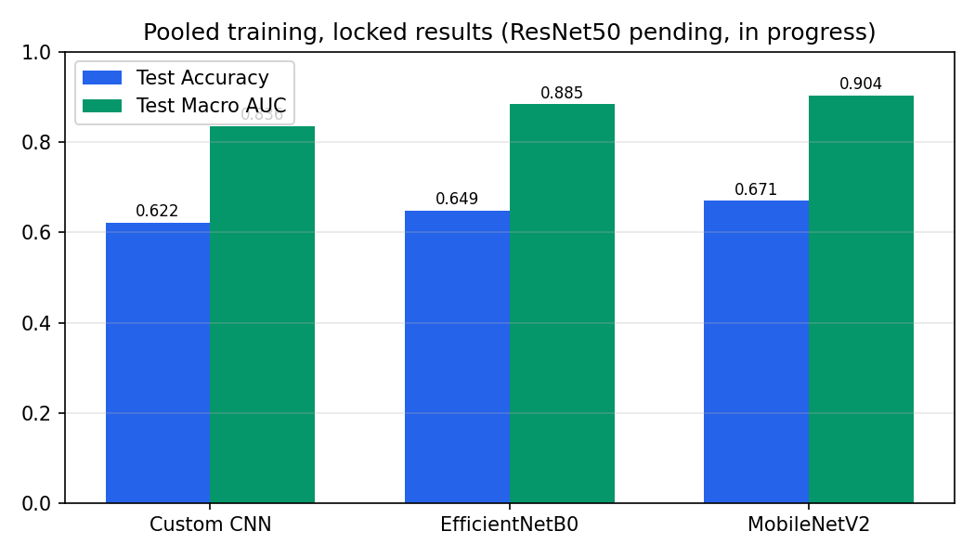
Figure 4.1: Locked pooled training results, accuracy and macro AUC, three completed models (ResNet50 pending)

Training curves
Each curve below shows training and validation accuracy, loss, and macro AUC across every real epoch of training that was actually logged in this project, generated directly from the logged numbers, not simulated or estimated.
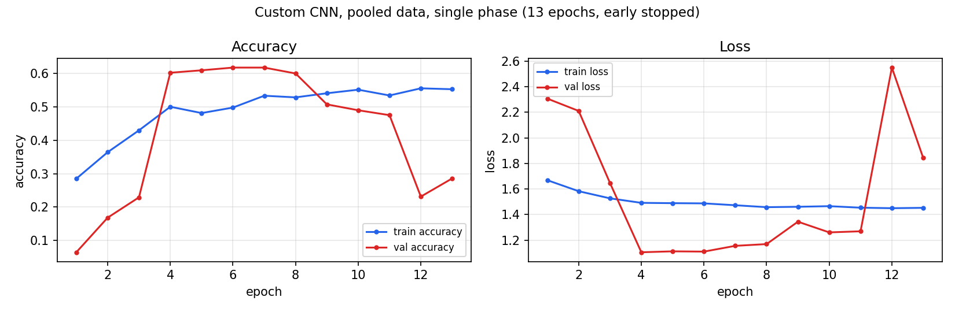
Figure 4.2: Custom CNN training curve, pooled data, single phase, 13 epochs (early stopped)
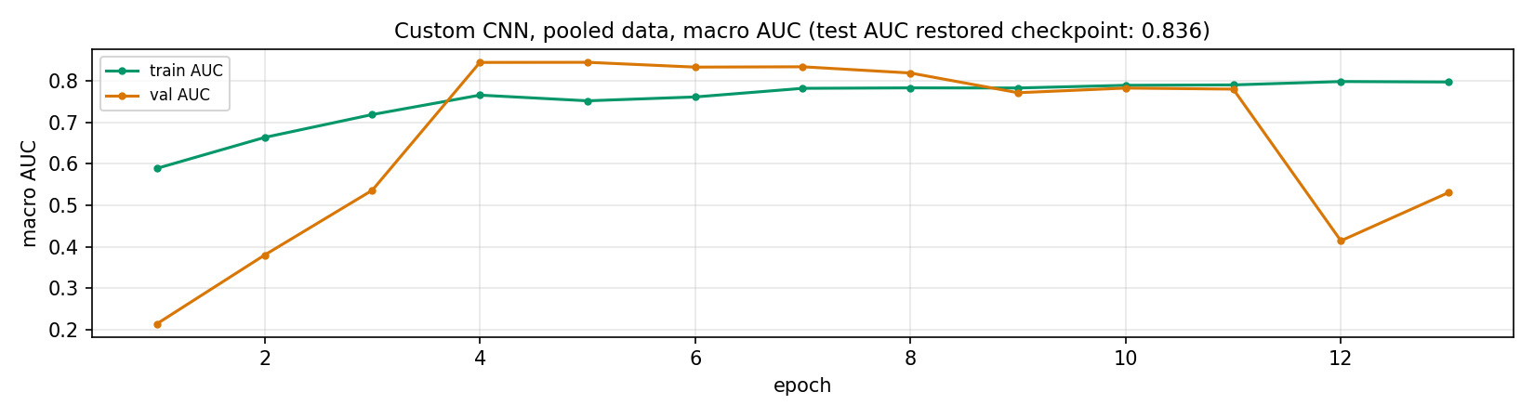
Figure 4.3: Custom CNN macro AUC curve, pooled data. Note the sharp drop at epoch 12, discussed below.
The Custom CNN run showed real training instability, not a smooth climb. Both validation accuracy and validation AUC crashed at epoch 1 (an expected cold start) and then crashed a second time, more seriously, at epoch 12, where validation accuracy fell to 0.23 and validation AUC fell to 0.41, right after a stable plateau across epochs 4 through 8 (validation accuracy around 0.60 to 0.62). Early stopping, configured to restore the best checkpoint rather than the final one, correctly kept the stable epoch 4 to 8 era model rather than the collapsed epoch 12 to 13 model, which is why the final locked test result (0.622 accuracy, 0.836 AUC) reflects the good, stable checkpoint. Notably, AUC stayed meaningfully healthier than accuracy through most of the instability, which became the reference pattern this project now watches for in later, more heavily imbalanced single source training runs.
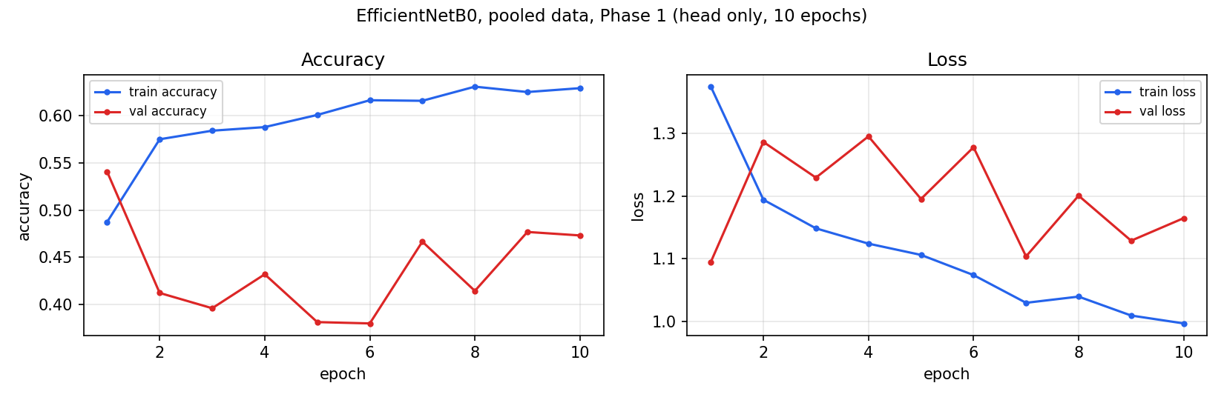
Figure 4.4: EfficientNetB0 training curve, pooled data, Phase 1 (head only), 10 epochs
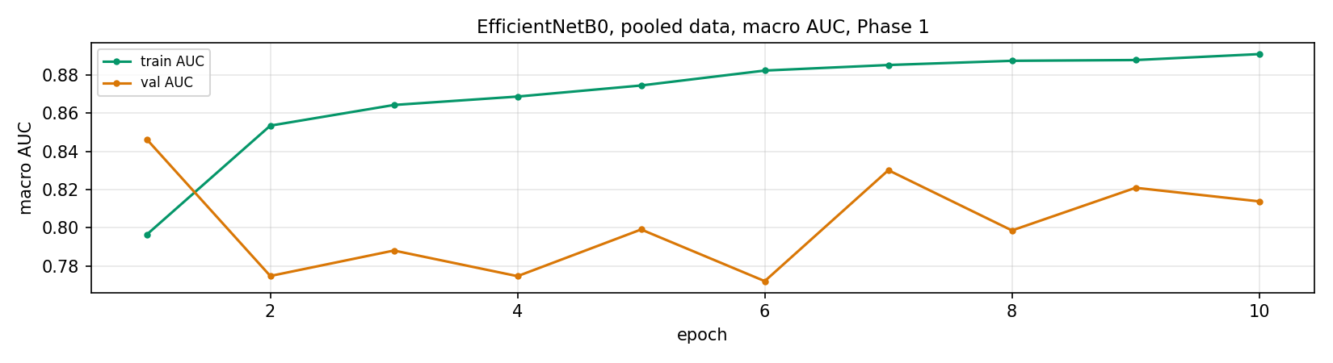
Figure 4.5: EfficientNetB0 macro AUC curve, pooled data, Phase 1
EfficientNetB0's Phase 1 (head only) training accuracy climbed steadily, but validation accuracy stayed choppy and never clearly separated from a mid-0.4 range, swinging between 0.38 and 0.54 across the 10 epochs with no clean upward trend. Validation macro AUC told a healthier story throughout, staying in the 0.77 to 0.85 range the whole time, the same accuracy-lags-AUC pattern seen elsewhere in this project's runs. This is worth noting as context for Phase 2 below, where the picture changes once the backbone is unfrozen.
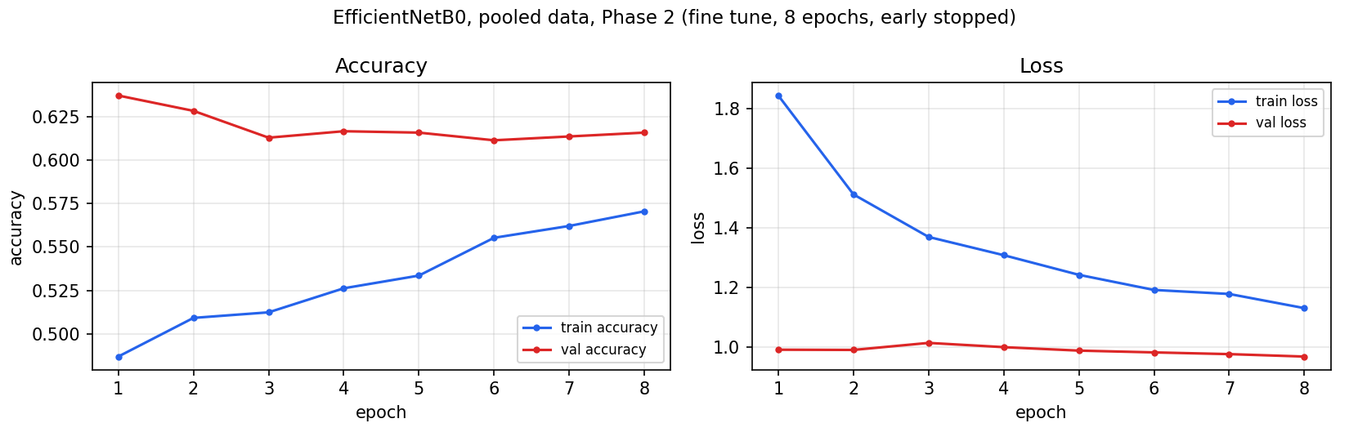
Figure 4.6: EfficientNetB0 training curve, pooled data, Phase 2 (fine tune), 8 epochs (early stopped)
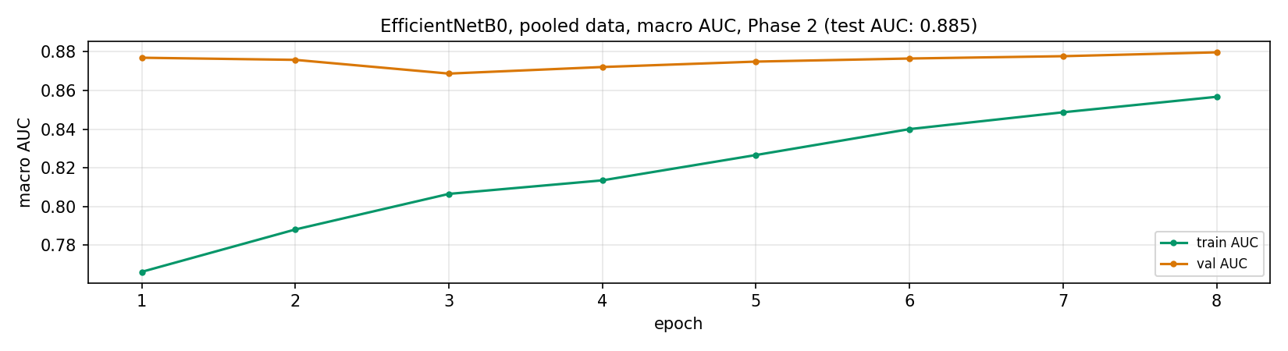
Figure 4.7: EfficientNetB0 macro AUC curve, pooled data, Phase 2
Once the backbone was unfrozen for Phase 2, EfficientNetB0's training was stable throughout, no collapse pattern, reaching its best validation performance and stopping cleanly at epoch 8. Validation accuracy in Phase 2 (settling around 0.61 to 0.64) is meaningfully higher and steadier than anything seen in Phase 1, which is the clearest evidence in this run that genuinely fine tuning the backbone, not just training a new head on top of frozen features, is what unlocks the model's real performance on this task.
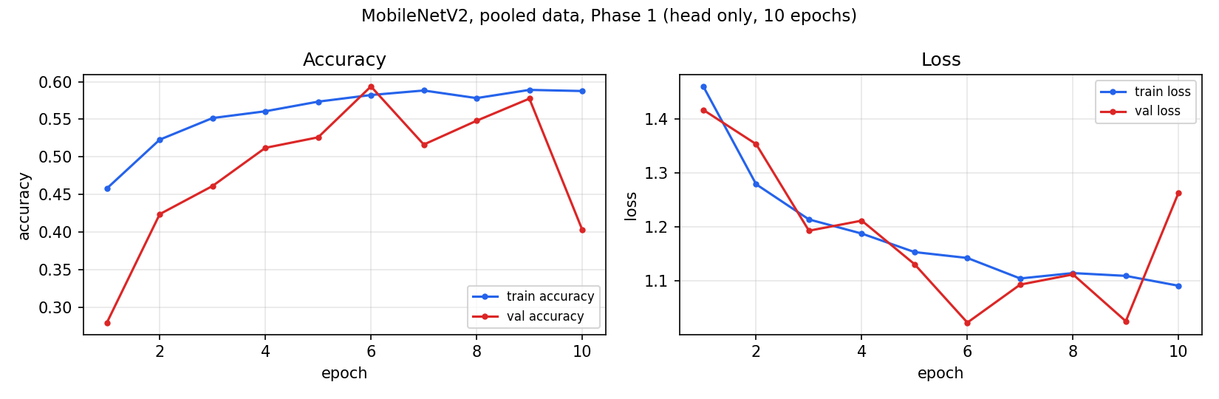
Figure 4.8: MobileNetV2 training curve, pooled data, Phase 1 (head only), 10 epochs
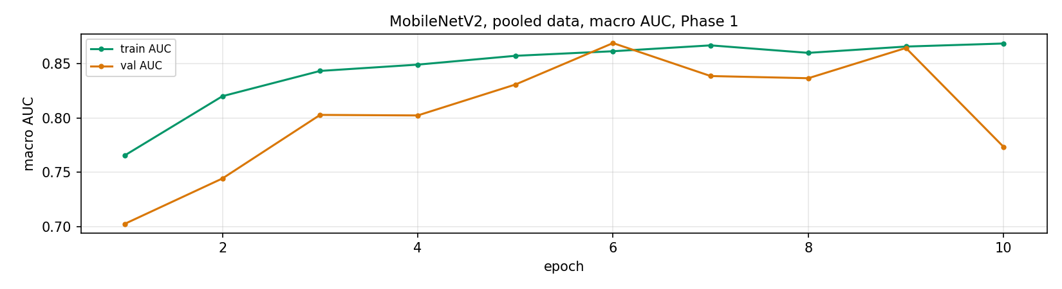
Figure 4.9: MobileNetV2 macro AUC curve, pooled data, Phase 1
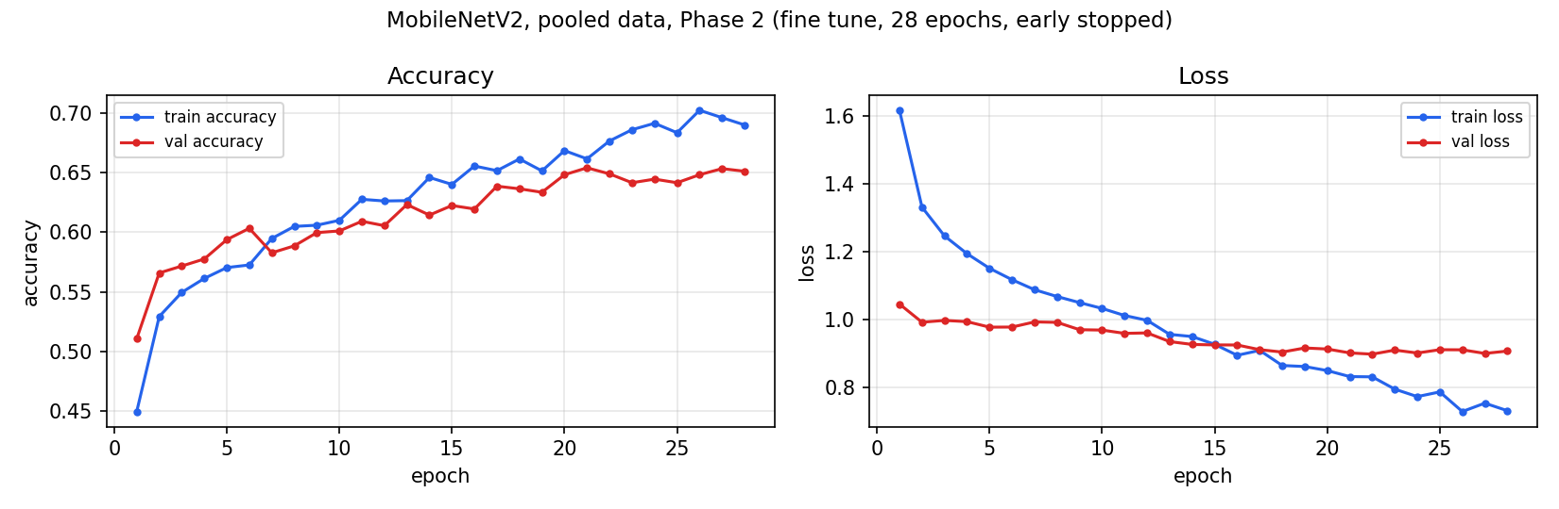
Figure 4.10: MobileNetV2 training curve, pooled data, Phase 2 (fine tune), 28 epochs (early stopped)
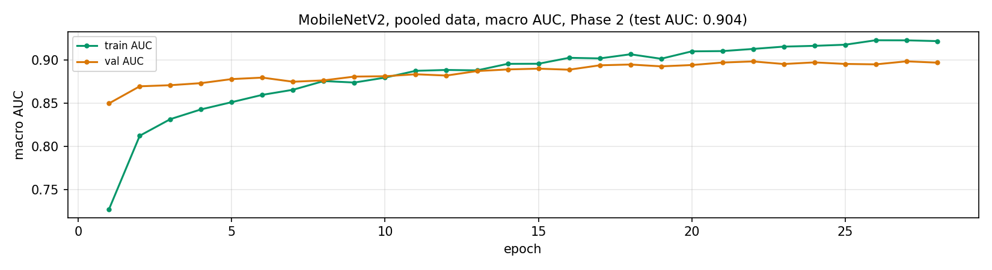
Figure 4.11: MobileNetV2 macro AUC curve, pooled data, Phase 2 (final test AUC: 0.904, the best result among completed models)
MobileNetV2's Phase 1 (head only) was notably rockier than EfficientNetB0's, validation accuracy dropped as low as 0.28 at epoch 1 and only reached 0.59 by epoch 6 before wobbling again. Phase 2, once the full backbone was unfrozen, recovered cleanly and trained steadily for the full 28 epochs before early stopping triggered, with no collapse pattern at any point.

5. What Is Left
- Stage 7 (ResNet50, pooled): currently in progress, Phase 1 complete, Phase 2 restarted after a session interruption, final result not yet available.
- Stage 8 (reload all four pooled models, confusion matrices): not started, waiting on Stage 7.
- Stage 9 and 10: not yet covered in detail in this project's working sessions so far.
- Stage 11 (12 single source training runs): not started. Per source class weights already computed and ready. Expected to be the highest risk stage for training instability, given that EyePACS and Messidor single source class weight spans (33.7x and 31.0x) are both roughly double the level associated with instability in the pooled Custom CNN run.
- Stage 12 (cross source evaluation matrix): not started, depends on Stage 11.
- Stage 13 (MMD, both directions, plus the added pooled model reference comparison): not started, depends on Stage 11, and requires the Stage 4 through 7 pooled model checkpoints to be kept, not discarded.
- Stage 14 (fine tune depth ablation): not started, depends on all pooled results being locked.
- Stage 15 (McNemar and DeLong statistical testing): not started, depends on all four pooled models being complete.
- Stage 16 (five fold cross validation or equivalent robustness check): not started. The exact scope of this stage (full five fold on all four models, or a reduced version) was flagged during this project's working sessions as an open decision needing input from the project supervisor, given real GPU quota and timeline constraints, and is not yet resolved as of this report.
- Stage 17 (final writeup): assembling everything above into the finished paper, once all prior stages are locked.
One additional open item worth stating plainly. During this project's working sessions, one dataset path (the location of previously saved model weights) was found to reference the wrong Kaggle account and was corrected. This is mentioned here not because it affected any locked result above (it did not, it was caught before it was used), but because it is a real, disclosed example of a mistake that was caught and fixed rather than one that slipped through, which is the same standard every number in this document is held to.

